**Setup**

All analyses are done in R using RStudio. For detailed session information including R version, operating system and package versions, see the sessionInfo() output at the end of this document.

All figures are produced with ggplot2.

* libraries

library(tidyverse) # for tidy data analysis

library(readr) # for fast reading of input files

library(mice) # mice package for Multivariate Imputation by Chained Equations (MICE)

**Data preparation**

**The dataset**

The dataset I am using in these example analyses, is the **Breast Cancer Wisconsin (Diagnostic) Dataset**. The data was downloaded from the [UC Irvine Machine Learning Repository](http://archive.ics.uci.edu/ml/datasets/Breast+Cancer+Wisconsin+%28Diagnostic%29).

The first dataset looks at the predictor classes:

* malignant or
* benign breast mass.

The features characterise cell nucleus properties and were generated from image analysis of [fine needle aspirates (FNA)](https://en.wikipedia.org/wiki/Fine-needle_aspiration) of breast masses:

* Sample ID (code number)
* Clump thickness
* Uniformity of cell size
* Uniformity of cell shape
* Marginal adhesion
* Single epithelial cell size
* Number of bare nuclei
* Bland chromatin
* Number of normal nuclei
* Mitosis
* Classes, i.e. diagnosis

bc_data <- read_delim("/Users/shiringlander/Documents/Github/intro_to_ml_workshop/intro_to_ml_uni_heidelberg/datasets/breast-cancer-wisconsin.data.txt",

delim = ",",

col_names = c("sample_code_number",

"clump_thickness",

"uniformity_of_cell_size",

"uniformity_of_cell_shape",

"marginal_adhesion",

"single_epithelial_cell_size",

"bare_nuclei",

"bland_chromatin",

"normal_nucleoli",

"mitosis",

"classes")) %>%

mutate(bare_nuclei = as.numeric(bare_nuclei),

classes = ifelse(classes == "2", "benign",

ifelse(classes == "4", "malignant", NA)))

summary(bc_data)

## sample_code_number clump_thickness uniformity_of_cell_size

## Min. : 61634 Min. : 1.000 Min. : 1.000

## 1st Qu.: 870688 1st Qu.: 2.000 1st Qu.: 1.000

## Median : 1171710 Median : 4.000 Median : 1.000

## Mean : 1071704 Mean : 4.418 Mean : 3.134

## 3rd Qu.: 1238298 3rd Qu.: 6.000 3rd Qu.: 5.000

## Max. :13454352 Max. :10.000 Max. :10.000

##

## uniformity_of_cell_shape marginal_adhesion single_epithelial_cell_size

## Min. : 1.000 Min. : 1.000 Min. : 1.000

## 1st Qu.: 1.000 1st Qu.: 1.000 1st Qu.: 2.000

## Median : 1.000 Median : 1.000 Median : 2.000

## Mean : 3.207 Mean : 2.807 Mean : 3.216

## 3rd Qu.: 5.000 3rd Qu.: 4.000 3rd Qu.: 4.000

## Max. :10.000 Max. :10.000 Max. :10.000

##

## bare_nuclei bland_chromatin normal_nucleoli mitosis

## Min. : 1.000 Min. : 1.000 Min. : 1.000 Min. : 1.000

## 1st Qu.: 1.000 1st Qu.: 2.000 1st Qu.: 1.000 1st Qu.: 1.000

## Median : 1.000 Median : 3.000 Median : 1.000 Median : 1.000

## Mean : 3.545 Mean : 3.438 Mean : 2.867 Mean : 1.589

## 3rd Qu.: 6.000 3rd Qu.: 5.000 3rd Qu.: 4.000 3rd Qu.: 1.000

## Max. :10.000 Max. :10.000 Max. :10.000 Max. :10.000

## NA's :16

## classes

## Length:699

## Class :character

## Mode :character

##

##

##

##

**Missing data**

# how many NAs are in the data

md.pattern(bc_data, plot = FALSE)

## sample_code_number clump_thickness uniformity_of_cell_size

## 683 1 1 1

## 16 1 1 1

## 0 0 0

## uniformity_of_cell_shape marginal_adhesion single_epithelial_cell_size

## 683 1 1 1

## 16 1 1 1

## 0 0 0

## bland_chromatin normal_nucleoli mitosis classes bare_nuclei

## 683 1 1 1 1 1 0

## 16 1 1 1 1 0 1

## 0 0 0 0 16 16

bc_data <- bc_data %>%

drop_na() %>%

select(classes, everything(), -sample_code_number)

head(bc_data)

## # A tibble: 6 x 10

## classes clump_thickness uniformity_of_cell_si… uniformity_of_cell_sha…

##

## 1 benign 5 1 1

## 2 benign 5 4 4

## 3 benign 3 1 1

## 4 benign 6 8 8

## 5 benign 4 1 1

## 6 malignant 8 10 10

## # ... with 6 more variables: marginal_adhesion ,

## # single_epithelial_cell_size , bare_nuclei ,

## # bland_chromatin , normal_nucleoli , mitosis

Missing values can be imputed with the *mice* package.

**Data exploration**

* Response variable for classification

ggplot(bc_data, aes(x = classes, fill = classes)) +

geom_bar()

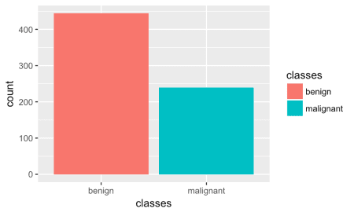

* Response variable for regression

ggplot(bc_data, aes(x = clump_thickness)) +

geom_histogram(bins = 10)

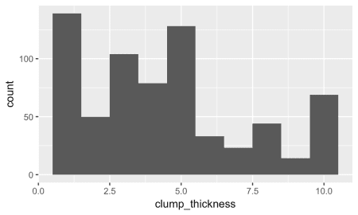

* Features

gather(bc_data, x, y, clump_thickness:mitosis) %>%

ggplot(aes(x = y, color = classes, fill = classes)) +

geom_density(alpha = 0.3) +

facet_wrap( ~ x, scales = "free", ncol = 3)

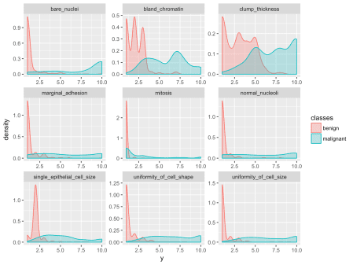

* Correlation graphs

co_mat_benign <- filter(bc_data, classes == "benign") %>%

select(-1) %>%

cor()

co_mat_malignant <- filter(bc_data, classes == "malignant") %>%

select(-1) %>%

cor()

library(igraph)

g_benign <- graph.adjacency(co_mat_benign,

weighted = TRUE,

diag = FALSE,

mode = "upper")

g_malignant <- graph.adjacency(co_mat_malignant,

weighted = TRUE,

diag = FALSE,

mode = "upper")

# http://kateto.net/networks-r-igraph

cut.off_b <- mean(E(g_benign)$weight)

cut.off_m <- mean(E(g_malignant)$weight)

g_benign_2 <- delete_edges(g_benign, E(g_benign)[weight < cut.off_b])

g_malignant_2 <- delete_edges(g_malignant, E(g_malignant)[weight < cut.off_m])

c_g_benign_2 <- cluster_fast_greedy(g_benign_2)

c_g_malignant_2 <- cluster_fast_greedy(g_malignant_2)

par(mfrow = c(1,2))

plot(c_g_benign_2, g_benign_2,

vertex.size = colSums(co_mat_benign) * 10,

vertex.frame.color = NA,

vertex.label.color = "black",

vertex.label.cex = 0.8,

edge.width = E(g_benign_2)$weight * 15,

layout = layout_with_fr(g_benign_2),

main = "Benign tumors")

plot(c_g_malignant_2, g_malignant_2,

vertex.size = colSums(co_mat_malignant) * 10,

vertex.frame.color = NA,

vertex.label.color = "black",

vertex.label.cex = 0.8,

edge.width = E(g_malignant_2)$weight * 15,

layout = layout_with_fr(g_malignant_2),

main = "Malignant tumors")

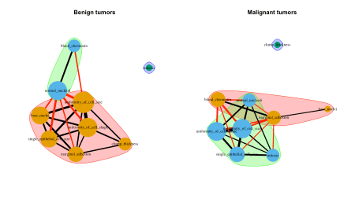

**Principal Component Analysis**

library(ellipse)

# perform pca and extract scores

pcaOutput <- prcomp(as.matrix(bc_data[, -1]), scale = TRUE, center = TRUE)

pcaOutput2 <- as.data.frame(pcaOutput$x)

# define groups for plotting

pcaOutput2$groups <- bc_data$classes

centroids <- aggregate(cbind(PC1, PC2) ~ groups, pcaOutput2, mean)

conf.rgn <- do.call(rbind, lapply(unique(pcaOutput2$groups), function(t)

data.frame(groups = as.character(t),

ellipse(cov(pcaOutput2[pcaOutput2$groups == t, 1:2]),

centre = as.matrix(centroids[centroids$groups == t, 2:3]),

level = 0.95),

stringsAsFactors = FALSE)))

ggplot(data = pcaOutput2, aes(x = PC1, y = PC2, group = groups, color = groups)) +

geom_polygon(data = conf.rgn, aes(fill = groups), alpha = 0.2) +

geom_point(size = 2, alpha = 0.6) +

labs(color = "",

fill = "")

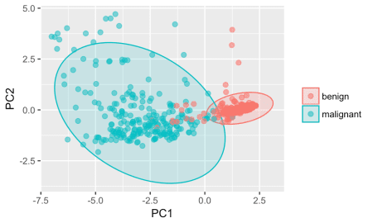

**Multidimensional Scaling**

select(bc_data, -1) %>%

dist() %>%

cmdscale %>%

as.data.frame() %>%

mutate(group = bc_data$classes) %>%

ggplot(aes(x = V1, y = V2, color = group)) +

geom_point()

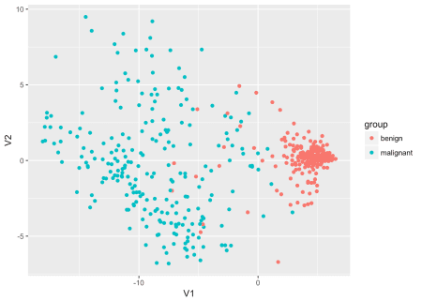

**t-SNE dimensionality reduction**

library(tsne)

select(bc_data, -1) %>%

dist() %>%

tsne() %>%

as.data.frame() %>%

mutate(group = bc_data$classes) %>%

ggplot(aes(x = V1, y = V2, color = group)) +

geom_point()

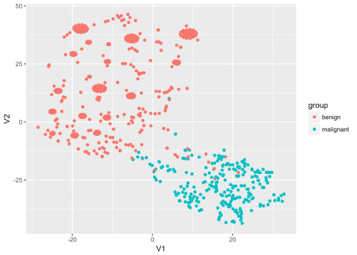

**Machine Learning packages for R**

# configure multicore

library(doParallel)

cl <- makeCluster(detectCores())

registerDoParallel(cl)

library(caret)

**Training, validation and test data**

set.seed(42)

index <- createDataPartition(bc_data$classes, p = 0.7, list = FALSE)

train_data <- bc_data[index, ]

test_data <- bc_data[-index, ]

bind_rows(data.frame(group = "train", train_data),

data.frame(group = "test", test_data)) %>%

gather(x, y, clump_thickness:mitosis) %>%

ggplot(aes(x = y, color = group, fill = group)) +

geom_density(alpha = 0.3) +

facet_wrap( ~ x, scales = "free", ncol = 3)

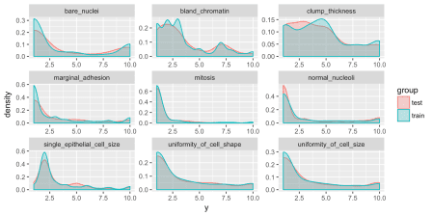

**Regression**

set.seed(42)

model_glm <- caret::train(clump_thickness ~ .,

data = train_data,

method = "glm",

preProcess = c("scale", "center"),

trControl = trainControl(method = "repeatedcv",

number = 10,

repeats = 10,

savePredictions = TRUE,

verboseIter = FALSE))

model_glm

## Generalized Linear Model

##

## 479 samples

## 9 predictor

##

## Pre-processing: scaled (9), centered (9)

## Resampling: Cross-Validated (10 fold, repeated 10 times)

## Summary of sample sizes: 432, 431, 432, 431, 431, 431, ...

## Resampling results:

##

## RMSE Rsquared MAE

## 1.972314 0.5254215 1.648832

predictions <- predict(model_glm, test_data)

# model_glm$finalModel$linear.predictors == model_glm$finalModel$fitted.values

data.frame(residuals = resid(model_glm),

predictors = model_glm$finalModel$linear.predictors) %>%

ggplot(aes(x = predictors, y = residuals)) +

geom_jitter() +

geom_smooth(method = "lm")

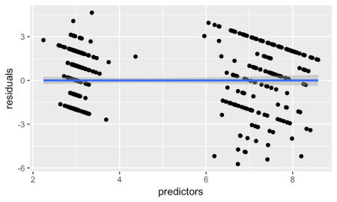

# y == train_data$clump_thickness

data.frame(residuals = resid(model_glm),

y = model_glm$finalModel$y) %>%

ggplot(aes(x = y, y = residuals)) +

geom_jitter() +

geom_smooth(method = "lm")

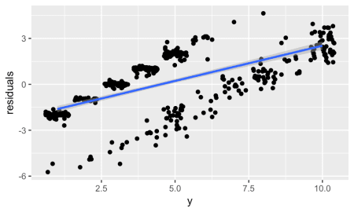

data.frame(actual = test_data$clump_thickness,

predicted = predictions) %>%

ggplot(aes(x = actual, y = predicted)) +

geom_jitter() +

geom_smooth(method = "lm")

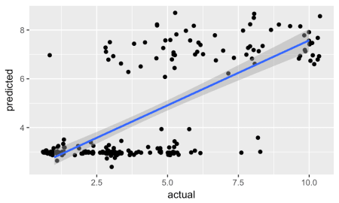

**Classification**

**Decision trees**

library(rpart)

library(rpart.plot)

set.seed(42)

fit <- rpart(classes ~ .,

data = train_data,

method = "class",

control = rpart.control(xval = 10,

minbucket = 2,

cp = 0),

parms = list(split = "information"))

rpart.plot(fit, extra = 100)

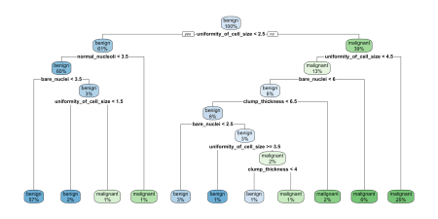

**Random Forests**

Random Forests predictions are based on the generation of multiple classification trees. They can be used for both, classification and regression tasks. Here, I show a classification task.

set.seed(42)

model_rf <- caret::train(classes ~ .,

data = train_data,

method = "rf",

preProcess = c("scale", "center"),

trControl = trainControl(method = "repeatedcv",

number = 5,

repeats = 3,

savePredictions = TRUE,

verboseIter = FALSE))

When you specify savePredictions = TRUE, you can access the cross-validation resuls with model_rf$pred.

model_rf

## Random Forest

##

## 479 samples

## 9 predictor

## 2 classes: 'benign', 'malignant'

##

## Pre-processing: scaled (9), centered (9)

## Resampling: Cross-Validated (10 fold, repeated 10 times)

## Summary of sample sizes: 432, 431, 431, 431, 431, 431, ...

## Resampling results across tuning parameters:

##

## mtry Accuracy Kappa

## 2 0.9776753 0.9513499

## 5 0.9757957 0.9469999

## 9 0.9714200 0.9370285

##

## Accuracy was used to select the optimal model using the largest value.

## The final value used for the model was mtry = 2.

model_rf$finalModel$confusion

## benign malignant class.error

## benign 304 7 0.02250804

## malignant 5 163 0.02976190

**Dealing with unbalanced data**

Luckily, caret makes it very easy to incorporate over- and under-sampling techniques with cross-validation resampling. We can simply add the sampling option to our trainControl and choose down for under- (also called down-) sampling. The rest stays the same as with our original model.

set.seed(42)

model_rf_down <- caret::train(classes ~ .,

data = train_data,

method = "rf",

preProcess = c("scale", "center"),

trControl = trainControl(method = "repeatedcv",

number = 10,

repeats = 10,

savePredictions = TRUE,

verboseIter = FALSE,

sampling = "down"))

model_rf_down

## Random Forest

##

## 479 samples

## 9 predictor

## 2 classes: 'benign', 'malignant'

##

## Pre-processing: scaled (9), centered (9)

## Resampling: Cross-Validated (10 fold, repeated 10 times)

## Summary of sample sizes: 432, 431, 431, 431, 431, 431, ...

## Addtional sampling using down-sampling prior to pre-processing

##

## Resampling results across tuning parameters:

##

## mtry Accuracy Kappa

## 2 0.9797503 0.9563138

## 5 0.9741198 0.9438326

## 9 0.9699578 0.9346310

##

## Accuracy was used to select the optimal model using the largest value.

## The final value used for the model was mtry = 2.

**Feature Importance**

imp <- model_rf$finalModel$importance

imp[order(imp, decreasing = TRUE), ]

## uniformity_of_cell_size uniformity_of_cell_shape

## 43.936945 39.840595

## bare_nuclei bland_chromatin

## 33.820345 31.984813

## normal_nucleoli single_epithelial_cell_size

## 21.686039 17.761202

## clump_thickness marginal_adhesion

## 16.318817 9.518437

## mitosis

## 2.220633

# estimate variable importance

importance <- varImp(model_rf, scale = TRUE)

plot(importance)

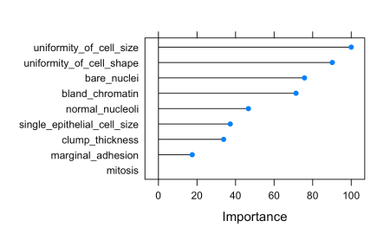

* predicting test data

confusionMatrix(predict(model_rf, test_data), as.factor(test_data$classes))

## Confusion Matrix and Statistics

##

## Reference

## Prediction benign malignant

## benign 128 4

## malignant 5 67

##

## Accuracy : 0.9559

## 95% CI : (0.9179, 0.9796)

## No Information Rate : 0.652

## P-Value [Acc > NIR] : <2e-16

##

## Kappa : 0.9031

## Mcnemar's Test P-Value : 1

##

## Sensitivity : 0.9624

## Specificity : 0.9437

## Pos Pred Value : 0.9697

## Neg Pred Value : 0.9306

## Prevalence : 0.6520

## Detection Rate : 0.6275

## Detection Prevalence : 0.6471

## Balanced Accuracy : 0.9530

##

## 'Positive' Class : benign

##

results <- data.frame(actual = test_data$classes,

predict(model_rf, test_data, type = "prob"))

results$prediction <- ifelse(results$benign > 0.5, "benign",

ifelse(results$malignant > 0.5, "malignant", NA))

results$correct <- ifelse(results$actual == results$prediction, TRUE, FALSE)

ggplot(results, aes(x = prediction, fill = correct)) +

geom_bar(position = "dodge")

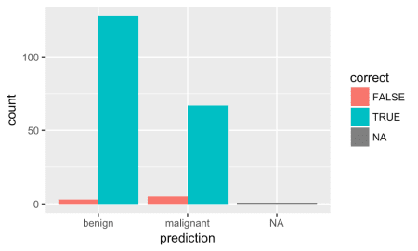

ggplot(results, aes(x = prediction, y = benign, color = correct, shape = correct)) +

geom_jitter(size = 3, alpha = 0.6)

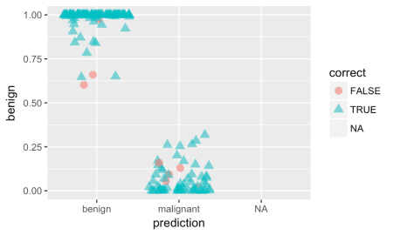

**Extreme gradient boosting trees**

“XGBoost uses a more regularized model formalization to control over-fitting, which gives it better performance.” Tianqi Chen, developer of xgboost

XGBoost is a tree ensemble model, which means the sum of predictions from a set of classification and regression trees (CART). In that, XGBoost is similar to Random Forests but it uses a different approach to model training. Can be used for classification and regression tasks. Here, I show a classification task.

set.seed(42)

model_xgb <- caret::train(classes ~ .,

data = train_data,

method = "xgbTree",

preProcess = c("scale", "center"),

trControl = trainControl(method = "repeatedcv",

number = 5,

repeats = 3,

savePredictions = TRUE,

verboseIter = FALSE))

model_xgb

## eXtreme Gradient Boosting

##

## 479 samples

## 9 predictor

## 2 classes: 'benign', 'malignant'

##

## Pre-processing: scaled (9), centered (9)

## Resampling: Cross-Validated (10 fold, repeated 10 times)

## Summary of sample sizes: 432, 431, 431, 431, 431, 431, ...

## Resampling results across tuning parameters:

##

## eta max_depth colsample_bytree subsample nrounds Accuracy

## 0.3 1 0.6 0.50 50 0.9567788

## 0.3 1 0.6 0.50 100 0.9544912

## 0.3 1 0.6 0.50 150 0.9513572

## 0.3 1 0.6 0.75 50 0.9576164

## 0.3 1 0.6 0.75 100 0.9536448

## 0.3 1 0.6 0.75 150 0.9525987

## 0.3 1 0.6 1.00 50 0.9559409

## 0.3 1 0.6 1.00 100 0.9555242

## 0.3 1 0.6 1.00 150 0.9551031

## 0.3 1 0.8 0.50 50 0.9718588

## 0.3 1 0.8 0.50 100 0.9720583

## 0.3 1 0.8 0.50 150 0.9699879

## 0.3 1 0.8 0.75 50 0.9726964

## 0.3 1 0.8 0.75 100 0.9724664

## 0.3 1 0.8 0.75 150 0.9705868

## 0.3 1 0.8 1.00 50 0.9714202

## 0.3 1 0.8 1.00 100 0.9710035

## 0.3 1 0.8 1.00 150 0.9705866

## 0.3 2 0.6 0.50 50 0.9559448

## 0.3 2 0.6 0.50 100 0.9565397

## 0.3 2 0.6 0.50 150 0.9555063

## 0.3 2 0.6 0.75 50 0.9530150

## 0.3 2 0.6 0.75 100 0.9550985

## 0.3 2 0.6 0.75 150 0.9551070

## 0.3 2 0.6 1.00 50 0.9532320

## 0.3 2 0.6 1.00 100 0.9551072

## 0.3 2 0.6 1.00 150 0.9557237

## 0.3 2 0.8 0.50 50 0.9720583

## 0.3 2 0.8 0.50 100 0.9735166

## 0.3 2 0.8 0.50 150 0.9720540

## 0.3 2 0.8 0.75 50 0.9722494

## 0.3 2 0.8 0.75 100 0.9726703

## 0.3 2 0.8 0.75 150 0.9716374

## 0.3 2 0.8 1.00 50 0.9716327

## 0.3 2 0.8 1.00 100 0.9724622

## 0.3 2 0.8 1.00 150 0.9718416

## 0.3 3 0.6 0.50 50 0.9548905

## 0.3 3 0.6 0.50 100 0.9557237

## 0.3 3 0.6 0.50 150 0.9555198

## 0.3 3 0.6 0.75 50 0.9561404

## 0.3 3 0.6 0.75 100 0.9546820

## 0.3 3 0.6 0.75 150 0.9552982

## 0.3 3 0.6 1.00 50 0.9577983

## 0.3 3 0.6 1.00 100 0.9573819

## 0.3 3 0.6 1.00 150 0.9567655

## 0.3 3 0.8 0.50 50 0.9733131

## 0.3 3 0.8 0.50 100 0.9728829

## 0.3 3 0.8 0.50 150 0.9718499

## 0.3 3 0.8 0.75 50 0.9751879

## 0.3 3 0.8 0.75 100 0.9743546

## 0.3 3 0.8 0.75 150 0.9735212

## 0.3 3 0.8 1.00 50 0.9743372

## 0.3 3 0.8 1.00 100 0.9737122

## 0.3 3 0.8 1.00 150 0.9743461

## 0.4 1 0.6 0.50 50 0.9548861

## 0.4 1 0.6 0.50 100 0.9528290

## 0.4 1 0.6 0.50 150 0.9498772

## 0.4 1 0.6 0.75 50 0.9557239

## 0.4 1 0.6 0.75 100 0.9513529

## 0.4 1 0.6 0.75 150 0.9492779

## 0.4 1 0.6 1.00 50 0.9559365

## 0.4 1 0.6 1.00 100 0.9551031

## 0.4 1 0.6 1.00 150 0.9536361

## 0.4 1 0.8 0.50 50 0.9710164

## 0.4 1 0.8 0.50 100 0.9697577

## 0.4 1 0.8 0.50 150 0.9687074

## 0.4 1 0.8 0.75 50 0.9710122

## 0.4 1 0.8 0.75 100 0.9707996

## 0.4 1 0.8 0.75 150 0.9691455

## 0.4 1 0.8 1.00 50 0.9705911

## 0.4 1 0.8 1.00 100 0.9697446

## 0.4 1 0.8 1.00 150 0.9697576

## 0.4 2 0.6 0.50 50 0.9544866

## 0.4 2 0.6 0.50 100 0.9542694

## 0.4 2 0.6 0.50 150 0.9536357

## 0.4 2 0.6 0.75 50 0.9540611

## 0.4 2 0.6 0.75 100 0.9542694

## 0.4 2 0.6 0.75 150 0.9549033

## 0.4 2 0.6 1.00 50 0.9540653

## 0.4 2 0.6 1.00 100 0.9555239

## 0.4 2 0.6 1.00 150 0.9546818

## 0.4 2 0.8 0.50 50 0.9720670

## 0.4 2 0.8 0.50 100 0.9695629

## 0.4 2 0.8 0.50 150 0.9702006

## 0.4 2 0.8 0.75 50 0.9722627

## 0.4 2 0.8 0.75 100 0.9720500

## 0.4 2 0.8 0.75 150 0.9716289

## 0.4 2 0.8 1.00 50 0.9726705

## 0.4 2 0.8 1.00 100 0.9708042

## 0.4 2 0.8 1.00 150 0.9708129

## 0.4 3 0.6 0.50 50 0.9555150

## 0.4 3 0.6 0.50 100 0.9553021

## 0.4 3 0.6 0.50 150 0.9548943

## 0.4 3 0.6 0.75 50 0.9555281

## 0.4 3 0.6 0.75 100 0.9563662

## 0.4 3 0.6 0.75 150 0.9555324

## 0.4 3 0.6 1.00 50 0.9575900

## 0.4 3 0.6 1.00 100 0.9571735

## 0.4 3 0.6 1.00 150 0.9559104

## 0.4 3 0.8 0.50 50 0.9737255

## 0.4 3 0.8 0.50 100 0.9745501

## 0.4 3 0.8 0.50 150 0.9730874

## 0.4 3 0.8 0.75 50 0.9747539

## 0.4 3 0.8 0.75 100 0.9724664

## 0.4 3 0.8 0.75 150 0.9720498

## 0.4 3 0.8 1.00 50 0.9747539

## 0.4 3 0.8 1.00 100 0.9749624

## 0.4 3 0.8 1.00 150 0.9734996

## Kappa

## 0.9050828

## 0.8999999

## 0.8930637

## 0.9067208

## 0.8982284

## 0.8959903

## 0.9028825

## 0.9022543

## 0.9014018

## 0.9382467

## 0.9386326

## 0.9340573

## 0.9400323

## 0.9395968

## 0.9353783

## 0.9372262

## 0.9362148

## 0.9353247

## 0.9032270

## 0.9047203

## 0.9024465

## 0.8968511

## 0.9015282

## 0.9016169

## 0.8971329

## 0.9015111

## 0.9028614

## 0.9387022

## 0.9419143

## 0.9387792

## 0.9391933

## 0.9401872

## 0.9379714

## 0.9377309

## 0.9397601

## 0.9384827

## 0.9008861

## 0.9029797

## 0.9024531

## 0.9037859

## 0.9004226

## 0.9019909

## 0.9074584

## 0.9064701

## 0.9051441

## 0.9414031

## 0.9405025

## 0.9380734

## 0.9456856

## 0.9438986

## 0.9419994

## 0.9438642

## 0.9426000

## 0.9439780

## 0.9007223

## 0.8964381

## 0.8897615

## 0.9027951

## 0.8931520

## 0.8886910

## 0.9030461

## 0.9014362

## 0.8982364

## 0.9363059

## 0.9334254

## 0.9311383

## 0.9361883

## 0.9357131

## 0.9320657

## 0.9353688

## 0.9333607

## 0.9334467

## 0.8999756

## 0.8997888

## 0.8983861

## 0.8991356

## 0.8998960

## 0.9013529

## 0.8990428

## 0.9023340

## 0.9004889

## 0.9387165

## 0.9332663

## 0.9345567

## 0.9393855

## 0.9389455

## 0.9380863

## 0.9401366

## 0.9361847

## 0.9361724

## 0.9021263

## 0.9017938

## 0.9010613

## 0.9025263

## 0.9043436

## 0.9024744

## 0.9069828

## 0.9059579

## 0.9031829

## 0.9424523

## 0.9442537

## 0.9410193

## 0.9447486

## 0.9397683

## 0.9388701

## 0.9449064

## 0.9454375

## 0.9422358

##

## Tuning parameter 'gamma' was held constant at a value of 0

##

## Tuning parameter 'min_child_weight' was held constant at a value of 1

## Accuracy was used to select the optimal model using the largest value.

## The final values used for the model were nrounds = 50, max_depth = 3,

## eta = 0.3, gamma = 0, colsample_bytree = 0.8, min_child_weight = 1

## and subsample = 0.75.

* Feature Importance

importance <- varImp(model_xgb, scale = TRUE)

plot(importance)

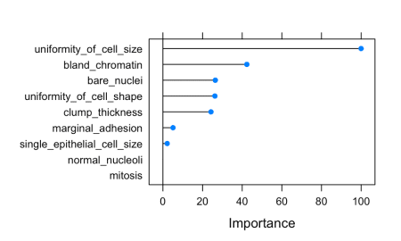

* predicting test data

confusionMatrix(predict(model_xgb, test_data), as.factor(test_data$classes))

## Confusion Matrix and Statistics

##

## Reference

## Prediction benign malignant

## benign 128 3

## malignant 5 68

##

## Accuracy : 0.9608

## 95% CI : (0.9242, 0.9829)

## No Information Rate : 0.652

## P-Value [Acc > NIR] : <2e-16

##

## Kappa : 0.9142

## Mcnemar's Test P-Value : 0.7237

##

## Sensitivity : 0.9624

## Specificity : 0.9577

## Pos Pred Value : 0.9771

## Neg Pred Value : 0.9315

## Prevalence : 0.6520

## Detection Rate : 0.6275

## Detection Prevalence : 0.6422

## Balanced Accuracy : 0.9601

##

## 'Positive' Class : benign

##

results <- data.frame(actual = test_data$classes,

predict(model_xgb, test_data, type = "prob"))

results$prediction <- ifelse(results$benign > 0.5, "benign",

ifelse(results$malignant > 0.5, "malignant", NA))

results$correct <- ifelse(results$actual == results$prediction, TRUE, FALSE)

ggplot(results, aes(x = prediction, fill = correct)) +

geom_bar(position = "dodge")

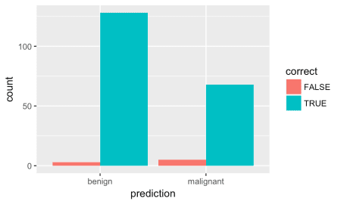

ggplot(results, aes(x = prediction, y = benign, color = correct, shape = correct)) +

geom_jitter(size = 3, alpha = 0.6)

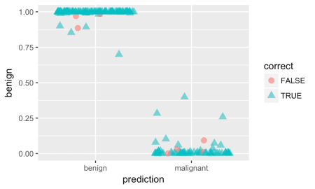

**Available models in caret**

**Feature Selection**

Performing feature selection on the whole dataset would lead to prediction bias, we therefore need to run the whole modeling process on the training data alone!

* Correlation

Correlations between all features are calculated and visualised with the *corrplot* package. I am then removing all features with a correlation higher than 0.7, keeping the feature with the lower mean.

library(corrplot)

# calculate correlation matrix

corMatMy <- cor(train_data[, -1])

corrplot(corMatMy, order = "hclust")

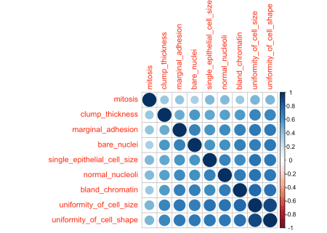

#Apply correlation filter at 0.70,

highlyCor <- colnames(train_data[, -1])[findCorrelation(corMatMy, cutoff = 0.7, verbose = TRUE)]

## Compare row 2 and column 3 with corr 0.908

## Means: 0.709 vs 0.594 so flagging column 2

## Compare row 3 and column 7 with corr 0.749

## Means: 0.67 vs 0.569 so flagging column 3

## All correlations <= 0.7

# which variables are flagged for removal?

highlyCor

## [1] "uniformity_of_cell_size" "uniformity_of_cell_shape"

#then we remove these variables

train_data_cor <- train_data[, which(!colnames(train_data) %in% highlyCor)]

* Recursive Feature Elimination (RFE)

Another way to choose features is with Recursive Feature Elimination. RFE uses a Random Forest algorithm to test combinations of features and rate each with an accuracy score. The combination with the highest score is usually preferential.

set.seed(7)

results_rfe <- rfe(x = train_data[, -1],

y = as.factor(train_data$classes),

sizes = c(1:9),

rfeControl = rfeControl(functions = rfFuncs, method = "cv", number = 10))

# chosen features

predictors(results_rfe)

## [1] "bare_nuclei" "clump_thickness"

## [3] "uniformity_of_cell_size" "uniformity_of_cell_shape"

## [5] "bland_chromatin" "normal_nucleoli"

## [7] "marginal_adhesion" "single_epithelial_cell_size"

train_data_rfe <- train_data[, c(1, which(colnames(train_data) %in% predictors(results_rfe)))]

* Genetic Algorithm (GA)

The Genetic Algorithm (GA) has been developed based on evolutionary principles of natural selection: It aims to optimize a population of individuals with a given set of genotypes by modeling selection over time. In each generation (i.e. iteration), each individual’s fitness is calculated based on their genotypes. Then, the fittest individuals are chosen to produce the next generation. This subsequent generation of individuals will have genotypes resulting from (re-) combinations of the parental alleles. These new genotypes will again determine each individual’s fitness. This selection process is iterated for a specified number of generations and (ideally) leads to fixation of the fittest alleles in the gene pool.

This concept of optimization can be applied to non-evolutionary models as well, like feature selection processes in machine learning.

set.seed(27)

model_ga <- gafs(x = train_data[, -1],

y = as.factor(train_data$classes),

iters = 10, # generations of algorithm

popSize = 10, # population size for each generation

levels = c("malignant", "benign"),

gafsControl = gafsControl(functions = rfGA, # Assess fitness with RF

method = "cv", # 10 fold cross validation

genParallel = TRUE, # Use parallel programming

allowParallel = TRUE))

plot(model_ga) # Plot mean fitness (AUC) by generation

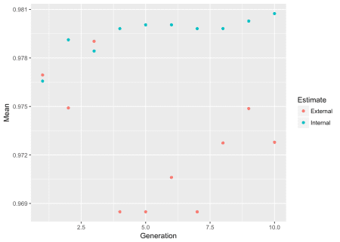

train_data_ga <- train_data[, c(1, which(colnames(train_data) %in% model_ga$ga$final))]

**Hyperparameter tuning with caret**

* Cartesian Grid
* mtry: Number of variables randomly sampled as candidates at each split.

set.seed(42)

grid <- expand.grid(mtry = c(1:10))

model_rf_tune_man <- caret::train(classes ~ .,

data = train_data,

method = "rf",

preProcess = c("scale", "center"),

trControl = trainControl(method = "repeatedcv",

number = 10,

repeats = 10,

savePredictions = TRUE,

verboseIter = FALSE),

tuneGrid = grid)

model_rf_tune_man

## Random Forest

##

## 479 samples

## 9 predictor

## 2 classes: 'benign', 'malignant'

##

## Pre-processing: scaled (9), centered (9)

## Resampling: Cross-Validated (10 fold, repeated 10 times)

## Summary of sample sizes: 432, 431, 431, 431, 431, 431, ...

## Resampling results across tuning parameters:

##

## mtry Accuracy Kappa

## 1 0.9785044 0.9532161

## 2 0.9772586 0.9504377

## 3 0.9774625 0.9508246

## 4 0.9766333 0.9488778

## 5 0.9753789 0.9460274

## 6 0.9737078 0.9422613

## 7 0.9730957 0.9408547

## 8 0.9714155 0.9371611

## 9 0.9718280 0.9380578

## 10 0.9718280 0.9380135

##

## Accuracy was used to select the optimal model using the largest value.

## The final value used for the model was mtry = 1.

plot(model_rf_tune_man)

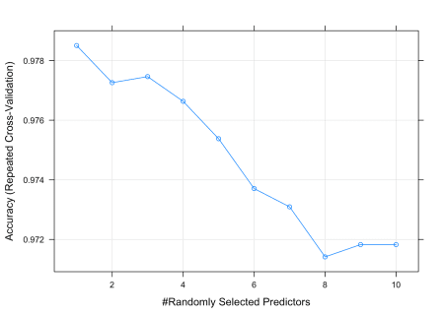

* Random Search

set.seed(42)

model_rf_tune_auto <- caret::train(classes ~ .,

data = train_data,

method = "rf",

preProcess = c("scale", "center"),

trControl = trainControl(method = "repeatedcv",

number = 10,

repeats = 10,

savePredictions = TRUE,

verboseIter = FALSE,

search = "random"),

tuneGrid = grid,

tuneLength = 15)

model_rf_tune_auto

## Random Forest

##

## 479 samples

## 9 predictor

## 2 classes: 'benign', 'malignant'

##

## Pre-processing: scaled (9), centered (9)

## Resampling: Cross-Validated (10 fold, repeated 10 times)

## Summary of sample sizes: 432, 431, 431, 431, 431, 431, ...

## Resampling results across tuning parameters:

##

## mtry Accuracy Kappa

## 1 0.9785044 0.9532161

## 2 0.9772586 0.9504377

## 3 0.9774625 0.9508246

## 4 0.9766333 0.9488778

## 5 0.9753789 0.9460274

## 6 0.9737078 0.9422613

## 7 0.9730957 0.9408547

## 8 0.9714155 0.9371611

## 9 0.9718280 0.9380578

## 10 0.9718280 0.9380135

##

## Accuracy was used to select the optimal model using the largest value.

## The final value used for the model was mtry = 1.

plot(model_rf_tune_auto)



**Grid search with h2o**

The R package h2o provides a convenient interface to H2O, which is an open-source machine learning and deep learning platform. H2O distributes a wide range of common machine learning algorithms for classification, regression and deep learning.

library(h2o)

h2o.init(nthreads = -1)

## Connection successful!

##

## R is connected to the H2O cluster:

## H2O cluster uptime: 26 minutes 45 seconds

## H2O cluster timezone: Europe/Berlin

## H2O data parsing timezone: UTC

## H2O cluster version: 3.20.0.2

## H2O cluster version age: 13 days

## H2O cluster name: H2O_started_from_R_shiringlander_jrj894

## H2O cluster total nodes: 1

## H2O cluster total memory: 3.24 GB

## H2O cluster total cores: 8

## H2O cluster allowed cores: 8

## H2O cluster healthy: TRUE

## H2O Connection ip: localhost

## H2O Connection port: 54321

## H2O Connection proxy: NA

## H2O Internal Security: FALSE

## H2O API Extensions: XGBoost, Algos, AutoML, Core V3, Core V4

## R Version: R version 3.5.0 (2018-04-23)

h2o.no_progress()

bc_data_hf <- as.h2o(bc_data)

h2o.describe(bc_data_hf) %>%

gather(x, y, Zeros:Sigma) %>%

mutate(group = ifelse(x %in% c("Min", "Max", "Mean"), "min, mean, max",

ifelse(x %in% c("NegInf", "PosInf"), "Inf", "sigma, zeros"))) %>%

ggplot(aes(x = Label, y = as.numeric(y), color = x)) +

geom_point(size = 4, alpha = 0.6) +

scale_color_brewer(palette = "Set1") +

theme(axis.text.x = element_text(angle = 45, vjust = 1, hjust = 1)) +

facet_grid(group ~ ., scales = "free") +

labs(x = "Feature",

y = "Value",

color = "")

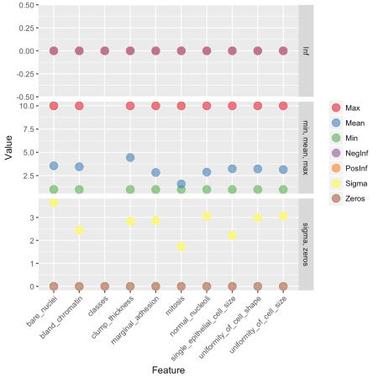

library(reshape2) # for melting

bc_data_hf[, 1] <- h2o.asfactor(bc_data_hf[, 1])

cor <- h2o.cor(bc_data_hf)

rownames(cor) <- colnames(cor)

melt(cor) %>%

mutate(Var2 = rep(rownames(cor), nrow(cor))) %>%

mutate(Var2 = factor(Var2, levels = colnames(cor))) %>%

mutate(variable = factor(variable, levels = colnames(cor))) %>%

ggplot(aes(x = variable, y = Var2, fill = value)) +

geom_tile(width = 0.9, height = 0.9) +

scale_fill_gradient2(low = "white", high = "red", name = "Cor.") +

theme(axis.text.x = element_text(angle = 90, vjust = 0.5, hjust = 1)) +

labs(x = "",

y = "")

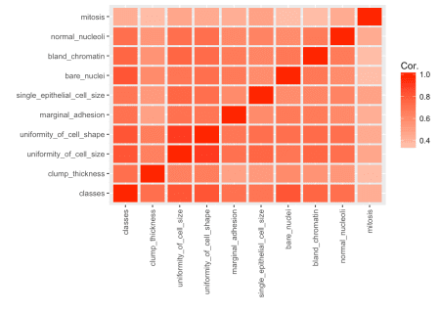

**Training, validation and test data**

splits <- h2o.splitFrame(bc_data_hf,

ratios = c(0.7, 0.15),

seed = 1)

train <- splits[[1]]

valid <- splits[[2]]

test <- splits[[3]]

response <- "classes"

features <- setdiff(colnames(train), response)

summary(as.factor(train$classes), exact_quantiles = TRUE)

## classes

## benign :313

## malignant:167

summary(as.factor(valid$classes), exact_quantiles = TRUE)

## classes

## benign :64

## malignant:38

summary(as.factor(test$classes), exact_quantiles = TRUE)

## classes

## benign :67

## malignant:34

pca <- h2o.prcomp(training_frame = train,

x = features,

validation_frame = valid,

transform = "NORMALIZE",

impute_missing = TRUE,

k = 3,

seed = 42)

eigenvec <- as.data.frame(pca@model$eigenvectors)

eigenvec$label <- features

library(ggrepel)

ggplot(eigenvec, aes(x = pc1, y = pc2, label = label)) +

geom_point(color = "navy", alpha = 0.7) +

geom_text_repel()

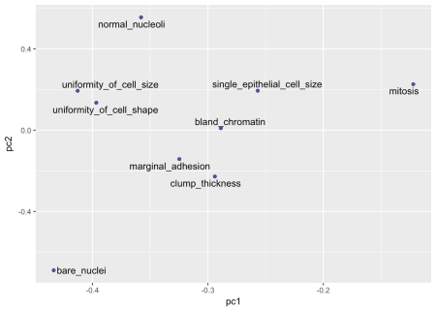

**Classification**

**Random Forest**

hyper_params <- list(

ntrees = c(25, 50, 75, 100),

max_depth = c(10, 20, 30),

min_rows = c(1, 3, 5)

)

search_criteria <- list(

strategy = "RandomDiscrete",

max_models = 50,

max_runtime_secs = 360,

stopping_rounds = 5,

stopping_metric = "AUC",

stopping_tolerance = 0.0005,

seed = 42

)

rf_grid <- h2o.grid(algorithm = "randomForest", # h2o.randomForest,

# alternatively h2o.gbm

# for Gradient boosting trees

x = features,

y = response,

grid_id = "rf_grid",

training_frame = train,

validation_frame = valid,

nfolds = 25,

fold_assignment = "Stratified",

hyper_params = hyper_params,

search_criteria = search_criteria,

seed = 42

)

# performance metrics where smaller is better -> order with decreasing = FALSE

sort_options_1 <- c("mean_per_class_error", "mse", "err", "logloss")

for (sort_by_1 in sort_options_1) {

grid <- h2o.getGrid("rf_grid", sort_by = sort_by_1, decreasing = FALSE)

model_ids <- grid@model_ids

best_model <- h2o.getModel(model_ids[[1]])

h2o.saveModel(best_model, path="models", force = TRUE)

}

# performance metrics where bigger is better -> order with decreasing = TRUE

sort_options_2 <- c("auc", "precision", "accuracy", "recall", "specificity")

for (sort_by_2 in sort_options_2) {

grid <- h2o.getGrid("rf_grid", sort_by = sort_by_2, decreasing = TRUE)

model_ids <- grid@model_ids

best_model <- h2o.getModel(model_ids[[1]])

h2o.saveModel(best_model, path = "models", force = TRUE)

}

files <- list.files(path = "/Users/shiringlander/Documents/Github/intro_to_ml_workshop/intro_to_ml_uni_heidelberg/models")

rf_models <- files[grep("rf_grid_model", files)]

for (model_id in rf_models) {

path <- paste0("/Users/shiringlander/Documents/Github/intro_to_ml_workshop/intro_to_ml_uni_heidelberg", "/models/", model_id)

best_model <- h2o.loadModel(path)

mse_auc_test <- data.frame(model_id = model_id,

mse = h2o.mse(h2o.performance(best_model, test)),

auc = h2o.auc(h2o.performance(best_model, test)))

if (model_id == rf_models[[1]]) {

mse_auc_test_comb <- mse_auc_test

} else {

mse_auc_test_comb <- rbind(mse_auc_test_comb, mse_auc_test)

}

}

mse_auc_test_comb %>%

gather(x, y, mse:auc) %>%

ggplot(aes(x = model_id, y = y, fill = model_id)) +

facet_grid(x ~ ., scales = "free") +

geom_bar(stat = "identity", alpha = 0.8, position = "dodge") +

scale_fill_brewer(palette = "Set1") +

theme(axis.text.x = element_text(angle = 45, vjust = 1, hjust = 1),

plot.margin = unit(c(0.5, 0, 0, 1.5), "cm")) +

labs(x = "", y = "value", fill = "")

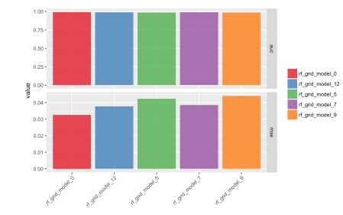

for (model_id in rf_models) {

best_model <- h2o.getModel(model_id)

finalRf_predictions <- data.frame(model_id = rep(best_model@model_id,

nrow(test)),

actual = as.vector(test$classes),

as.data.frame(h2o.predict(object = best_model,

newdata = test)))

finalRf_predictions$accurate <- ifelse(finalRf_predictions$actual ==

finalRf_predictions$predict,

"yes", "no")

finalRf_predictions$predict_stringent <- ifelse(finalRf_predictions$benign > 0.8,

"benign",

ifelse(finalRf_predictions$malignant

> 0.8, "malignant", "uncertain"))

finalRf_predictions$accurate_stringent <- ifelse(finalRf_predictions$actual ==

finalRf_predictions$predict_stringent, "yes",

ifelse(finalRf_predictions$predict_stringent ==

"uncertain", "na", "no"))

if (model_id == rf_models[[1]]) {

finalRf_predictions_comb <- finalRf_predictions

} else {

finalRf_predictions_comb <- rbind(finalRf_predictions_comb, finalRf_predictions)

}

}

finalRf_predictions_comb %>%

ggplot(aes(x = actual, fill = accurate)) +

geom_bar(position = "dodge") +

scale_fill_brewer(palette = "Set1") +

facet_wrap(~ model_id, ncol = 2) +

labs(fill = "Were\npredictions\naccurate?",

title = "Default predictions")

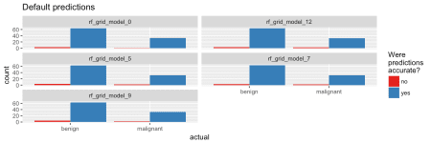

finalRf_predictions_comb %>%

subset(accurate_stringent != "na") %>%

ggplot(aes(x = actual, fill = accurate_stringent)) +

geom_bar(position = "dodge") +

scale_fill_brewer(palette = "Set1") +

facet_wrap(~ model_id, ncol = 2) +

labs(fill = "Were\npredictions\naccurate?",

title = "Stringent predictions")

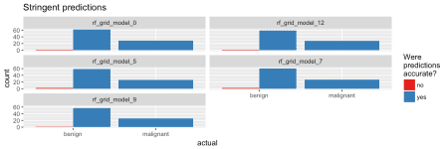

rf_model <- h2o.loadModel("/Users/shiringlander/Documents/Github/intro_to_ml_workshop/intro_to_ml_uni_heidelberg/models/rf_grid_model_0")

h2o.varimp_plot(rf_model)

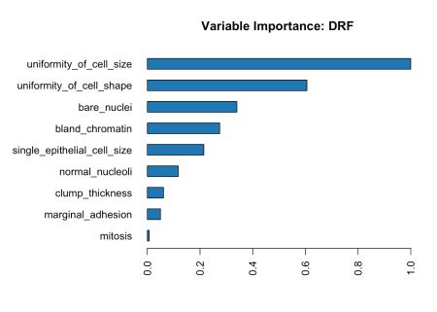

#h2o.varimp(rf_model)

h2o.mean_per_class_error(rf_model, train = TRUE, valid = TRUE, xval = TRUE)

## train valid xval

## 0.02196246 0.02343750 0.02515735

h2o.confusionMatrix(rf_model, valid = TRUE)

## Confusion Matrix (vertical: actual; across: predicted) for max f1 @ threshold = 0.533333333333333:

## benign malignant Error Rate

## benign 61 3 0.046875 =3/64

## malignant 0 38 0.000000 =0/38

## Totals 61 41 0.029412 =3/102

plot(rf_model,

timestep = "number_of_trees",

metric = "classification_error")

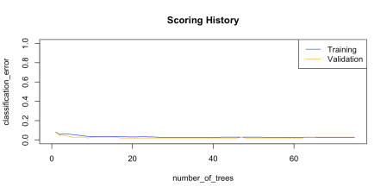

plot(rf_model,

timestep = "number_of_trees",

metric = "logloss")

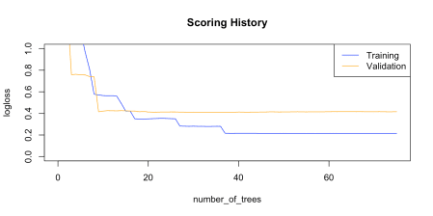

plot(rf_model,

timestep = "number_of_trees",

metric = "AUC")

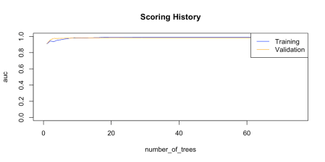

plot(rf_model,

timestep = "number_of_trees",

metric = "rmse")



h2o.auc(rf_model, train = TRUE)

## [1] 0.9907214

h2o.auc(rf_model, valid = TRUE)

## [1] 0.9829359

h2o.auc(rf_model, xval = TRUE)

## [1] 0.9903005

perf <- h2o.performance(rf_model, test)

perf

## H2OBinomialMetrics: drf

##

## MSE: 0.03258482

## RMSE: 0.1805127

## LogLoss: 0.1072519

## Mean Per-Class Error: 0.02985075

## AUC: 0.9916594

## Gini: 0.9833187

##

## Confusion Matrix (vertical: actual; across: predicted) for F1-optimal threshold:

## benign malignant Error Rate

## benign 63 4 0.059701 =4/67

## malignant 0 34 0.000000 =0/34

## Totals 63 38 0.039604 =4/101

##

## Maximum Metrics: Maximum metrics at their respective thresholds

## metric threshold value idx

## 1 max f1 0.306667 0.944444 18

## 2 max f2 0.306667 0.977011 18

## 3 max f0point5 0.720000 0.933735 13

## 4 max accuracy 0.533333 0.960396 16

## 5 max precision 1.000000 1.000000 0

## 6 max recall 0.306667 1.000000 18

## 7 max specificity 1.000000 1.000000 0

## 8 max absolute_mcc 0.306667 0.917235 18

## 9 max min_per_class_accuracy 0.533333 0.955224 16

## 10 max mean_per_class_accuracy 0.306667 0.970149 18

##

## Gains/Lift Table: Extract with `h2o.gainsLift(, )` or `h2o.gainsLift(, valid=, xval=)`

plot(perf)

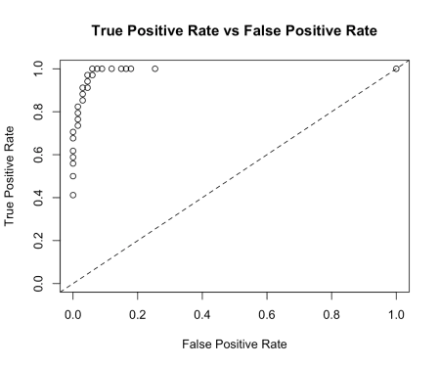

perf@metrics$thresholds_and_metric_scores %>%

ggplot(aes(x = fpr, y = tpr)) +

geom_point() +

geom_line() +

geom_abline(slope = 1, intercept = 0) +

labs(x = "False Positive Rate",

y = "True Positive Rate")



h2o.logloss(perf)

## [1] 0.1072519

h2o.mse(perf)

## [1] 0.03258482

h2o.auc(perf)

## [1] 0.9916594

head(h2o.metric(perf))

## Metrics for Thresholds: Binomial metrics as a function of classification thresholds

## threshold f1 f2 f0point5 accuracy precision recall

## 1 1.000000 0.583333 0.466667 0.777778 0.801980 1.000000 0.411765

## 2 0.986667 0.666667 0.555556 0.833333 0.831683 1.000000 0.500000

## 3 0.973333 0.716981 0.612903 0.863636 0.851485 1.000000 0.558824

## 4 0.960000 0.740741 0.641026 0.877193 0.861386 1.000000 0.588235

## 5 0.946667 0.763636 0.668790 0.889831 0.871287 1.000000 0.617647

## 6 0.920000 0.807018 0.723270 0.912698 0.891089 1.000000 0.676471

## specificity absolute_mcc min_per_class_accuracy mean_per_class_accuracy

## 1 1.000000 0.563122 0.411765 0.705882

## 2 1.000000 0.631514 0.500000 0.750000

## 3 1.000000 0.675722 0.558824 0.779412

## 4 1.000000 0.697542 0.588235 0.794118

## 5 1.000000 0.719221 0.617647 0.808824

## 6 1.000000 0.762280 0.676471 0.838235

## tns fns fps tps tnr fnr fpr tpr idx

## 1 67 20 0 14 1.000000 0.588235 0.000000 0.411765 0

## 2 67 17 0 17 1.000000 0.500000 0.000000 0.500000 1

## 3 67 15 0 19 1.000000 0.441176 0.000000 0.558824 2

## 4 67 14 0 20 1.000000 0.411765 0.000000 0.588235 3

## 5 67 13 0 21 1.000000 0.382353 0.000000 0.617647 4

## 6 67 11 0 23 1.000000 0.323529 0.000000 0.676471 5

finalRf_predictions <- data.frame(actual = as.vector(test$classes),

as.data.frame(h2o.predict(object = rf_model,

newdata = test)))

finalRf_predictions$accurate <- ifelse(finalRf_predictions$actual ==

finalRf_predictions$predict, "yes", "no")

finalRf_predictions$predict_stringent <- ifelse(finalRf_predictions$benign > 0.8, "benign",

ifelse(finalRf_predictions$malignant

> 0.8, "malignant", "uncertain"))

finalRf_predictions$accurate_stringent <- ifelse(finalRf_predictions$actual ==

finalRf_predictions$predict_stringent, "yes",

ifelse(finalRf_predictions$predict_stringent ==

"uncertain", "na", "no"))

finalRf_predictions %>%

group_by(actual, predict) %>%

dplyr::summarise(n = n())

## # A tibble: 4 x 3

## # Groups: actual [?]

## actual predict n

##

## 1 benign benign 64

## 2 benign malignant 3

## 3 malignant benign 1

## 4 malignant malignant 33

finalRf_predictions %>%

group_by(actual, predict_stringent) %>%

dplyr::summarise(n = n())

## # A tibble: 5 x 3

## # Groups: actual [?]

## actual predict_stringent n

##

## 1 benign benign 62

## 2 benign malignant 2

## 3 benign uncertain 3

## 4 malignant malignant 29

## 5 malignant uncertain 5

finalRf_predictions %>%

ggplot(aes(x = actual, fill = accurate)) +

geom_bar(position = "dodge") +

scale_fill_brewer(palette = "Set1") +

labs(fill = "Were\npredictions\naccurate?",

title = "Default predictions")

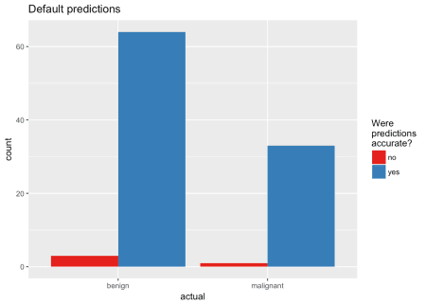

finalRf_predictions %>%

subset(accurate_stringent != "na") %>%

ggplot(aes(x = actual, fill = accurate_stringent)) +

geom_bar(position = "dodge") +

scale_fill_brewer(palette = "Set1") +

labs(fill = "Were\npredictions\naccurate?",

title = "Stringent predictions")

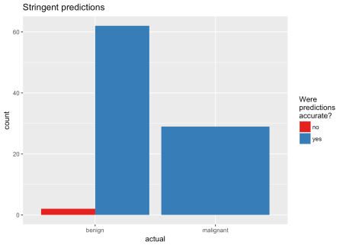

df <- finalRf_predictions[, c(1, 3, 4)]

thresholds <- seq(from = 0, to = 1, by = 0.1)

prop_table <- data.frame(threshold = thresholds, prop_true_b = NA, prop_true_m = NA)

for (threshold in thresholds) {

pred <- ifelse(df$benign > threshold, "benign", "malignant")

pred_t <- ifelse(pred == df$actual, TRUE, FALSE)

group <- data.frame(df, "pred" = pred_t) %>%

group_by(actual, pred) %>%

dplyr::summarise(n = n())

group_b <- filter(group, actual == "benign")

prop_b <- sum(filter(group_b, pred == TRUE)$n) / sum(group_b$n)

prop_table[prop_table$threshold == threshold, "prop_true_b"] <- prop_b

group_m <- filter(group, actual == "malignant")

prop_m <- sum(filter(group_m, pred == TRUE)$n) / sum(group_m$n)

prop_table[prop_table$threshold == threshold, "prop_true_m"] <- prop_m

}

prop_table %>%

gather(x, y, prop_true_b:prop_true_m) %>%

ggplot(aes(x = threshold, y = y, color = x)) +

geom_point() +

geom_line() +

scale_color_brewer(palette = "Set1") +

labs(y = "proportion of true predictions",

color = "b: benign cases\nm: malignant cases")

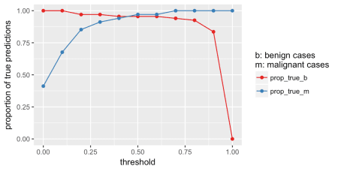

stopCluster(cl)

h2o.shutdown()

## Are you sure you want to shutdown the H2O instance running at http://localhost:54321/ (Y/N)?

sessionInfo()

## R version 3.5.0 (2018-04-23)

## Platform: x86_64-apple-darwin15.6.0 (64-bit)

## Running under: macOS High Sierra 10.13.5

##

## Matrix products: default

## BLAS: /Library/Frameworks/R.framework/Versions/3.5/Resources/lib/libRblas.0.dylib

## LAPACK: /Library/Frameworks/R.framework/Versions/3.5/Resources/lib/libRlapack.dylib

##

## locale:

## [1] de_DE.UTF-8/de_DE.UTF-8/de_DE.UTF-8/C/de_DE.UTF-8/de_DE.UTF-8

##

## attached base packages:

## [1] parallel stats graphics grDevices utils datasets methods

## [8] base

##

## other attached packages:

## [1] ggrepel_0.8.0 reshape2_1.4.3 h2o_3.20.0.2

## [4] corrplot_0.84 caret_6.0-80 doParallel_1.0.11

## [7] iterators_1.0.9 foreach_1.4.4 ellipse_0.4.1

## [10] igraph_1.2.1 bindrcpp_0.2.2 mice_3.1.0

## [13] lattice_0.20-35 forcats_0.3.0 stringr_1.3.1

## [16] dplyr_0.7.5 purrr_0.2.5 readr_1.1.1

## [19] tidyr_0.8.1 tibble_1.4.2 ggplot2_2.2.1

## [22] tidyverse_1.2.1

##

## loaded via a namespace (and not attached):

## [1] minqa_1.2.4 colorspace_1.3-2 class_7.3-14

## [4] rprojroot_1.3-2 pls_2.6-0 rstudioapi_0.7

## [7] DRR_0.0.3 prodlim_2018.04.18 lubridate_1.7.4

## [10] xml2_1.2.0 codetools_0.2-15 splines_3.5.0

## [13] mnormt_1.5-5 robustbase_0.93-1 knitr_1.20

## [16] RcppRoll_0.3.0 jsonlite_1.5 nloptr_1.0.4

## [19] broom_0.4.4 ddalpha_1.3.4 kernlab_0.9-26

## [22] sfsmisc_1.1-2 compiler_3.5.0 httr_1.3.1

## [25] backports_1.1.2 assertthat_0.2.0 Matrix_1.2-14

## [28] lazyeval_0.2.1 cli_1.0.0 htmltools_0.3.6

## [31] tools_3.5.0 gtable_0.2.0 glue_1.2.0

## [34] Rcpp_0.12.17 cellranger_1.1.0 nlme_3.1-137

## [37] blogdown_0.6 psych_1.8.4 timeDate_3043.102

## [40] xfun_0.2 gower_0.1.2 lme4_1.1-17

## [43] rvest_0.3.2 pan_1.4 DEoptimR_1.0-8

## [46] MASS_7.3-50 scales_0.5.0 ipred_0.9-6

## [49] hms_0.4.2 RColorBrewer_1.1-2 yaml_2.1.19

## [52] rpart_4.1-13 stringi_1.2.3 randomForest_4.6-14

## [55] e1071_1.6-8 lava_1.6.1 geometry_0.3-6

## [58] bitops_1.0-6 rlang_0.2.1 pkgconfig_2.0.1

## [61] evaluate_0.10.1 bindr_0.1.1 recipes_0.1.3

## [64] labeling_0.3 CVST_0.2-2 tidyselect_0.2.4

## [67] plyr_1.8.4 magrittr_1.5 bookdown_0.7

## [70] R6_2.2.2 mitml_0.3-5 dimRed_0.1.0

## [73] pillar_1.2.3 haven_1.1.1 foreign_0.8-70

## [76] withr_2.1.2 RCurl_1.95-4.10 survival_2.42-3

## [79] abind_1.4-5 nnet_7.3-12 modelr_0.1.2

## [82] crayon_1.3.4 jomo_2.6-2 xgboost_0.71.2

## [85] utf8_1.1.4 rmarkdown_1.10 grid_3.5.0

## [88] readxl_1.1.0 data.table_1.11.4 ModelMetrics_1.1.0

## [91] digest_0.6.15 stats4_3.5.0 munsell_0.5.0

## [94] magic_1.5-8